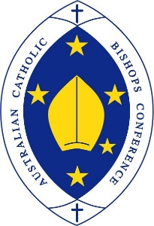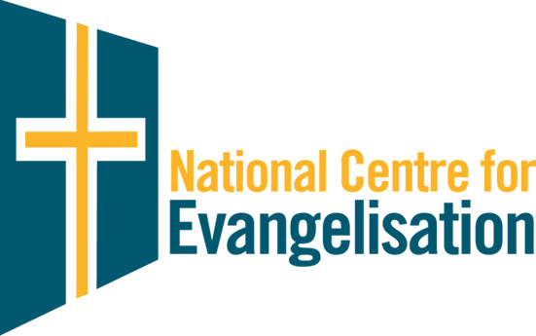

**JOINT MEDIA RELEASE**    **MARCH 8, 2024**

**AUSTRALIAN CATHOLIC BISHOPS CONFERENCE AND NATIONAL CENTRE FOR EVANGELISATION**

**International Women’s Day 2024**

Highlighting the dignity of women is the focus of two new resources being released to mark International Women’s Day (Friday, March 8).

The first resource is a [prayer](https://nce.catholic.org.au/images/events/International_Womens_Day_Prayer_2024-compressed_1.pdf) of gratitude for women of our past, present and future, which can be used in a variety of settings. Parishes and dioceses are invited to share it with parishioners, groups and movements among their members, and Catholic agencies among their staff and clients, as appropriate.

The second resource is a new video series on [Evangelise Plus](https://www.evangeliseplus.com.au/), featuring five outstanding Catholic leaders discussing women’s leadership. Professor Rose Amal, Dr Trudy Dantis, Sr Melissa Dwyer, Qwayne Guevara and Dr Ursula Stephens share their wisdom gleaned from many years leading in Catholic and secular settings. The resource is accompanied by a “How to use” document. This document, together with the videos, provides a rich stimulus for small group dialogue.

“We are very grateful to these five leaders for sharing their time, talent and thought-provoking responses to our questions on female leadership,” the National Centre for Evangelisation’s Sharon Brewer said.

“Each of these women, in their paid and volunteer work, contribute significantly to raising the dignity of women through research, formation and accompaniment.”

The Bishop’s Delegate for Women, Bishop Michael Morrissey, said it was important for the Church to celebrate International Women’s Day.

“Each year, when we celebrate International Women’s Day, we are reminded of the ongoing need to take stock of how we are enabling the dignity and equality of women and bringing it the fore,” he said.

“We endeavour to always ask ourselves, ‘Am I following Jesus’ lead and actively calling out injustice when I see it in the workplace, in the home, in society, and indeed – in our Church?’ This is an ongoing challenge for us all.”

Coinciding with International Women’s Day, participants in the [Young Catholic Women’s Fellowship](https://nce.catholic.org.au/womensfellowship), an initiative of the Australian bishops, are gathering at Mary MacKillop Place and the Australian Catholic University in Sydney this weekend.

The NCE invites Catholics to pray for these [eight young women](https://nce.catholic.org.au/the-bridge/the-bridge/young-catholic-women-s-fellowship-commences) as they begin their journey of formation for mission leadership.

*The National Centre for Evangelisation is an office of the Bishops Commission for Evangelisation, Laity and Ministry.*

**VIDEO OF AN INTERVIEW WITH CLARA GEOGHEGAN (EXECUTIVE SECRETARY OF THE BISHOPS COMMISSION FOR EVANGELISATION, LAITY AND MINISTRY) AND RAYLA BARCELONA (DEPUTY DIRECTOR, AUSTRALIAN CATHOLIC MIGRANT AND REFUGEE OFFICE) IS AVAILABLE** [**HERE**](https://www.youtube.com/watch?v=Xk7C5OMteqQ)

**Media Contact:**

Paul Osborne,   
Australian Catholic Bishops Conference   
Media and Communications Director   
P: 0407 519 473   
[media@catholic.org.au](mailto:media@catholic.org.au)